

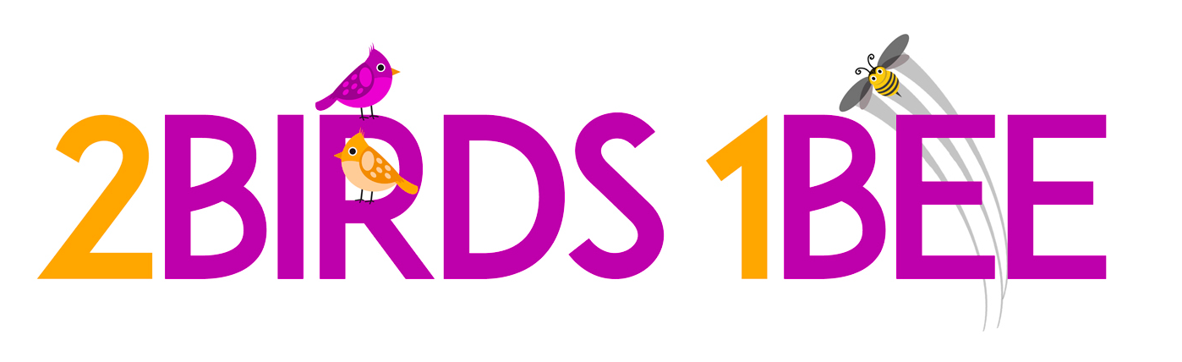

School Prospectus

2 Birds 1 Bee

2 Birds 1 Bee is a youth-run relationships and sex education company. It’s dual aims (‘hitting two birds with one stone’) are to provide educational content that compliments the school curriculum, and to smash taboos. 2 Birds 1 Bee delivers workshops and presentations to students, parents, and schools in order to open the space for more conversation. All workshops are based on both academic and primary research, and presented in a highly engaging way.



A note on workshops

Each school is different, with different concerns, cultural factors, and circumstances. The workshops here are highly flexible to get the most out of them in each setting, and can be adapted for any age group in years 7-12.

They are also somewhat flexible in form to match the logistical realities of interrupting a school schedule, however the structure which encourages most interactivity and depth is to have multiple 1.5 – 2 hour workshops delivered to classroom sized groups.

XXXposed – Taking porn out from under the covers

Rationale

Pornography may be difficult to talk about, but it’s also very easy to access in almost infinite quantities. By the age of 16over 90% of boys and 60% of girls in Australia have been exposed to pornography (Flemming et al 2006), and studies suggest the **average** age of first exposure to online pornography is 11 years old. Mainstream music videos, films, and advertising have also become ‘pornified’, setting a new norm for sexuality. The myths espoused by porn are incredibly damaging to development and relationships, and have been linked with broader issues of mental ill-health and sexual assault.

Note

The following are non-compulsory but have been learnt from past successes. It is recommended that this workshop:

* Is preceded by the equivalent talk for parents (*iBirds and eBees: Parenting in the 21st Century* – see below) in the week before delivering this workshop. This allows the program to gain parents’ trust, and equips parents to continue the conversation at home.
* Includes an opt-out option for parents and students uncomfortable with the topic, even after the parent information talk.
* Is divided by gender when presented in order to create more discussion.

Content

This workshop is designed to correct the myths created by porn in three key areas – body image, gender roles, and ‘sexpectations’ – and to discuss the growing issue of porn addiction.

**Introduction**

Designed to create a safe and open space for discussion, the introductory ice breakers are all about shattering the taboos around pornography and sex

**Body Image**

The pressures on young people to look a certain way has never been this intense, and it’s no wonder when the bodies they are exposed to are so unrealistic. Although other aspects are commonly discussed, it is lesser known that almost one in two men are concerned by the size of their penises (Wylie and Eardly 2007) nor that the fastest growing cosmetic surgery in Australia is labia plasticity (plastic surgery on the labia to fit the ‘pornstar vagina’ look). In line with research, this section tackles body-image issues through education, by providing averages and discussions about the effect of porn on body image.

**Gender roles**

Most mainstream pornography is made for a ‘(heterosexual) male gaze’, and presents incredibly toxic ideas of gender relations. Women are treated as passive objects existing only for male pleasure, whereas men are expected to fill a highly aggressive role of dominance. Using music videos as a substitute, this section discusses the damaging effect of such expectations for all genders, as well as ways of challenging them.

**Sexpectations**

Much like learning to drive from the *Fast and Furious* franchise, porn creates an inaccurate Hollywood-ised set of expectations around sex – or ‘sexpectations’. Studies are worryingly showing that young people are increasingly expecting their partners to play out the scenes they’re watching online, including the violence (both physical and verbal), high prevalence of anal sex, and the lack of protection or consent. Through ’10 myths’, this section challenges the normalisation of these practises and underscores the importance of consent in relationships.

**Porn addiction**

Online pornography is a super-natural stimulant, and there is an increasing number of young people (including women) who have so strongly wired their pleasure neurons with pornography that they develop addiction symptoms. Included in this is the tendency towards ‘escalation’ into more shocking pornography genres, and an inability to enjoy real sex. This section of the workshop delves into the brain science behind it all and practical things young people can do to avoid those pitfalls.

**Debrief**

The debrief includes a summary, reflection, and opportunity for questions. It is also a time to point out a list of available resources and reemphasise the importance of continuing the conversations outside the workshop. A feedback survey is also distributed in this time.

*The e-birds and ibees –* Parenting in the 21st Century

Rational

Parenting is never easy, but when it comes to talking about sex, relationships or porn it can be difficult to even know where to start. Despite the rise of online pornography, the role of parents is no less important – indeed, it may be more important than ever. Yet simply giving ‘the Talk’ is no longer enough. This workshop provides a model for how parents can approach relationship and sex education in the information age, and provides practical pointers on both what needs to be spoken about and how young people can be engaged in what is too often an uncomfortable space.

In conjunction with *XXXposed – Bringing porn out from beneath the covers*, this 1.5 hour workshop is highly useful in allaying parental concerns and creating lasting conversations.

Content

This workshop is very flexible and with enough information and notice can be adapted to reflect the particular concerns of the school. The base of the presentation content is below.

**Rethinking sex-education**

Australia has a relatively conservative sex-education culture in which the priority is placed almost exclusively on pregnancy prevention and disease control. This section turns to Western and Northern Europe as an example of a sex education culture that has broader priorities of mental and sexual health and enjoyment, and also scores better on traditional metrics of physical safety.

**Young people and pornography**

Most parents are understandably concerned by the realities of online pornography. This section gives them a structured way of thinking about how to most effectively deal with their concerns. It very closely links in with the corresponding workshop delivered to students, and gives a common set of tools and language that can help continue the conversation at home.

**Parents and sex education**

Most parents are as comfortable talking to their children about sex as their children are in talking to them. Based on surveys and research, this section covers what most young people want from their parents, both in terms of which topics should be broached and how those conversations can happen (spoiler: ‘the Talk’ is *not* appreciated).

*LGBTQIA…WTF?* – Gender and Sexuality diversity

Rationale

According to government estimates, 11% of Australians have a diverse gender and/or sexuality identification, and mental illnesses like depression are three times more common amongst these demographics, particularly in young people. When 80% of homophobic bullying occurs in schools, it is clear that more education around gender and sexuality are needed. Understanding these topics benefits everyone by helping to challenge gender roles and myths about sexuality.

Content

**Relevance**

In any given classroom, it is statistically probable that 2-3 students will have a diverse gender or sexuality identification. The LGBTQIA+ community forms a highly significant minority, and understanding gender and sexuality is the key to combating ignorant bullying and discrimination. It’s also useful to everyone to understand how expectations around such topics are restrictive.

**Sex and Gender**

An exploration of sex (biological distinctions) - including intersex conditions – and gender (social expectations attached to sex). By identifying gender as a social construct, we are able to challenge why women are discriminated against, and why men are more than three times more likely to commit suicide. Discussions include how gender is relevant to the students themselves, and what they can do to challenge these roles. It introduces a more fluid and flexible understanding of both sex and gender than the traditional ideas of binary.

**Sexuality**

This section briefly identifies the main theories and myths surrounding sexuality, normalising its diversity.

**LGBTQIA+ and Identity Politics**

What do those letters actually mean? And more importantly – who are the people behind them? This section provides a small overview of different gender and sexuality identifications, highlighting statistics and the big issues facing each group. It finishes with the vital discussion of *why* such labels can be so important to those who identify with them, and what can be done to support them.